Forecasting Methods Homework Report for Question-2

A-) Simple exponential smoothing was performed and the lambda coefficient was found to be 0.99, approximately one. This means that the model only makes predictions based on the previous prediction. In short, we can call it naive forecasting.

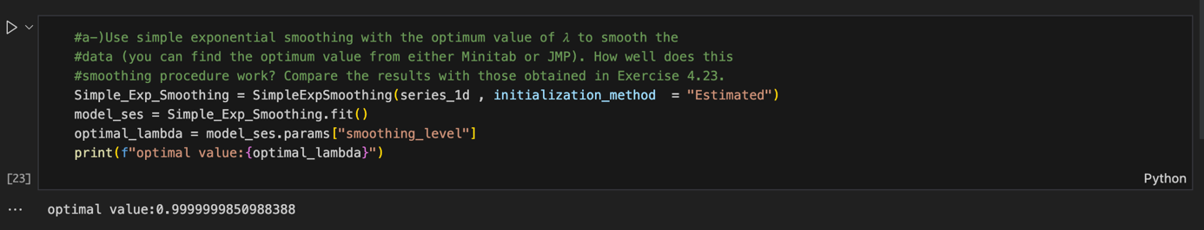

B-) Yes, using the optimum value of the smoothing constant is important for forecasting, and the position of this value between 0 and 1 is also important. As it approaches 0, the model stops giving weight to new values. As it approaches 1, it starts giving weight to new values ​​and stops giving weight to old values.

C-) No significant difference was observed with the Holt trend. Although the fitted values ​​closely followed the actual series, no significant difference was observed according to SES.

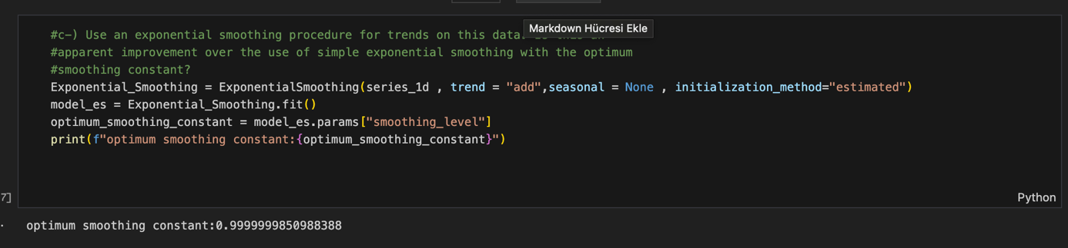

D-) By taking difference, we made the series stationary, the trend effect was eliminated, and the variance was stabilized.
